Preemption and Scheduling
# Source: AI Source: Provided by: [Data Path: Persons Table -> ID Column: 1, Name_En Column: Motasem Essam] -> From: [ChatGPT] on [1/21/2026]
Preemption and Scheduling is a key resource management technique in Real-Time Systems (RTS) that ensures timely execution of high-priority tasks and efficient CPU utilization.

Definition
# Source: AI Source: Provided by: [Data Path: Persons Table -> ID Column: 1, Name_En Column: Motasem Essam] -> From: [ChatGPT] on [1/21/2026]
- Preemption is the ability of a higher-priority task to interrupt a currently running lower-priority task to gain immediate access to the CPU or other critical resources.
- Scheduling is the process of deciding the order in which tasks execute based on priorities, deadlines, or system policies.
Together, they ensure that resources are allocated efficiently and that critical tasks meet their deadlines.

Key Features
# Source: AI Source: Provided by: [Data Path: Persons Table -> ID Column: 1, Name_En Column: Motasem Essam] -> From: [ChatGPT] on [1/21/2026]
- Preemptive Execution
  - High-priority tasks can interrupt lower-priority tasks.
  - Ensures timely response for critical tasks.
- Task Scheduling
  - Determines which task runs next on the CPU or uses a shared resource.
  - Can be static (fixed priorities) or dynamic (priority changes at runtime).
- Resource Management
  - Preemption helps avoid resource blocking and ensures that important tasks are not delayed.
  - Works with mutexes, semaphores, and monitors to coordinate access to shared resources.

Example
# Source: AI Source: Provided by: [Data Path: Persons Table -> ID Column: 1, Name_En Column: Motasem Essam] -> From: [ChatGPT] on [1/21/2026]
Suppose three tasks in a real-time system:
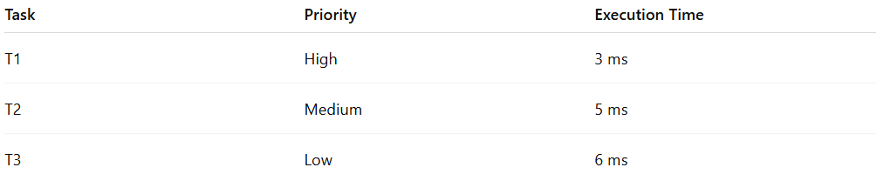
Task | Priority | Execution Time
T1 | High | 3 ms
T2 | Medium | 5 ms
T3 | Low | 6 ms
Scenario:
- T3 starts executing first.
- T1 becomes ready → preempts T3 and executes immediately.
- After T1 finishes, T3 resumes from where it left off.
- T2 executes when CPU is free.
- Preemption ensures high-priority tasks meet deadlines, even if lower-priority tasks are running.

Advantages
# Source: AI Source: Provided by: [Data Path: Persons Table -> ID Column: 1, Name_En Column: Motasem Essam] -> From: [ChatGPT] on [1/21/2026]
- Improves responsiveness for critical tasks.
- Efficient CPU utilization by allowing tasks to share CPU based on priority.
- Works well with real-time scheduling algorithms (RMS, EDF, LLF).

Disadvantages
# Source: AI Source: Provided by: [Data Path: Persons Table -> ID Column: 1, Name_En Column: Motasem Essam] -> From: [ChatGPT] on [1/21/2026]
- Context switching overhead – frequent preemption increases CPU load.
- Requires careful management to avoid priority inversion.
- Can be complex to implement in systems with many tasks and resources.

Why Preemption and Scheduling Matter for Software Engineers
# Source: AI Source: Provided by: [Data Path: Persons Table -> ID Column: 1, Name_En Column: Motasem Essam] -> From: [ChatGPT] on [1/21/2026]
- Fundamental for designing real-time systems that meet strict deadlines.
- Helps understand task prioritization, context switching, and resource management.
- Widely used in RTOS, embedded systems, robotics, automotive, and industrial automation.

